**IOT-Smart parking**

*NAME : N.Nibiya Rose*

*ID : aut962921104708*

*EMAIL : nibiyanibiya6@gmail.com*

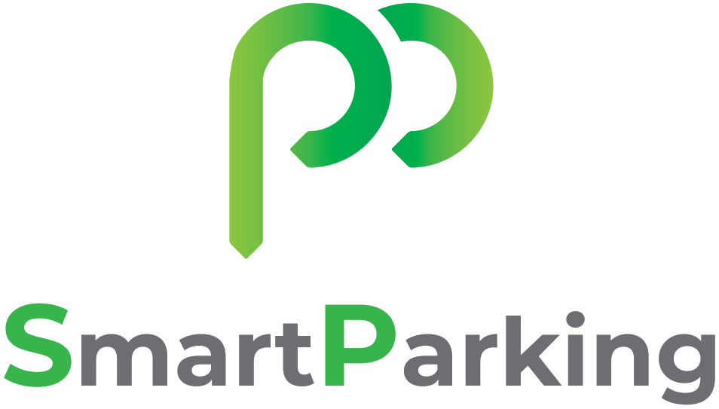



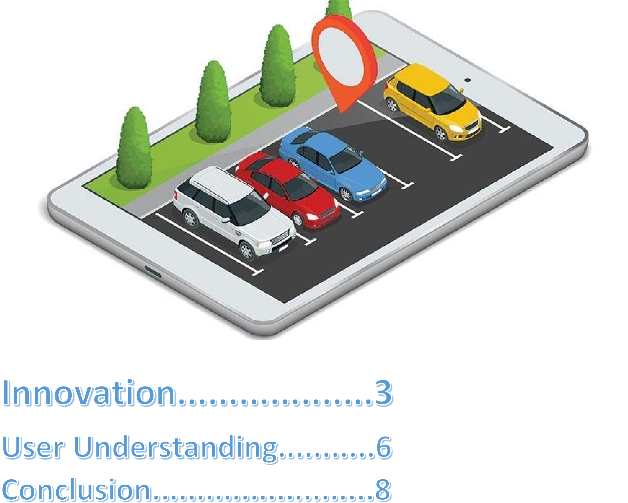





According to ITS America’s Market Analysis, almost 30% of congestion in urban areas is caused by drivers cruising around looking for parking space due to a dearth of[*parking innovations*.](https://www.happiestminds.com/Insights/smart-parking/)  Not only does this mean that there is excess traffic on the roads, but it also results in oil wastage as well – one of the world’s fast-depleting natural resources. Read more about smart parking innovations

Smart parking solutions are designed to reduce this uncertainty in finding parking space, payments, etc. When the number of cars on the road is only increasing every day, these kinds of solutions are desperately required. Here are the top 11 revolutionary smart parking innovations:

1. **Wireless sensor technology:**To provide real-time parking data to drivers, the Internet of Things is foremost in importance. Smart parking companies have installed more than 10,000 wireless devices worldwide, and many of these systems can include guidance when visitors try to find space in your company’s car park or at any other public space.
2. **Valet parking:**In some airports like Dusseldorf, Germany, drivers may have the pleasure of experiencing the latest parking technology and having their car picked up and parked by robotic valets, like Stan who is manufactured by Stanley Robotics, a harbinger of future parking.
3. **Parking apps:**Apps like PayByPhone and Park Right are integral to smart parking systems and allow you to pay for your parking, along with extending the duration if you are going to stay for longer than intended. Some of them may even tell you where you can find parking spaces.
4. **Fully-automated garages:**In Boulder, Colorado, a fully[*automated garage*](https://blog.getmyparking.com/2018/08/31/what-happens-to-your-car-in-an-automated-parking-garage/)is being installed when cars can be scanned with lasers and parked by robotic valets. Then, they are transported by an automatic dolly to multi-level storage racks. This means that this garage can hold up to 4 times as many cars as normal.
5. **Self-parking cars:** With the coming of the newest technology in cars, Audi and the city of Somerville in Massachusetts have partnered to work on self-driving and [*self-parking cars*.](https://blog.getmyparking.com/2019/04/11/20-best-self-parking-cars-of-2019/) The advantage to these is that the driver can get off right next to their destination while the cars can park themselves, reducing congestion.

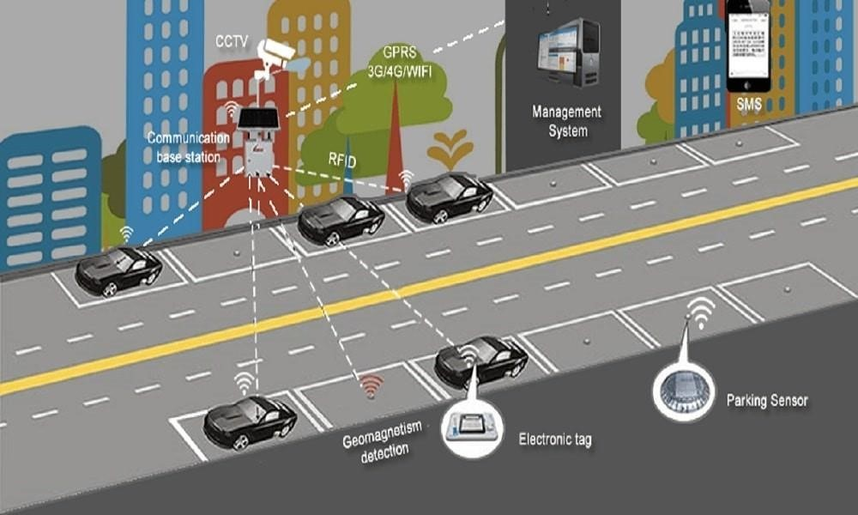



1. Introduction Smart parking is a niche field in which many companies are now investing heavily and the car parking industry has tremendous potential since the parking problems in developing and developed countries is increasing. Internet of things (KANG, 2011) [3] is the next internet revolution which is going to trigger machine to machine communication.

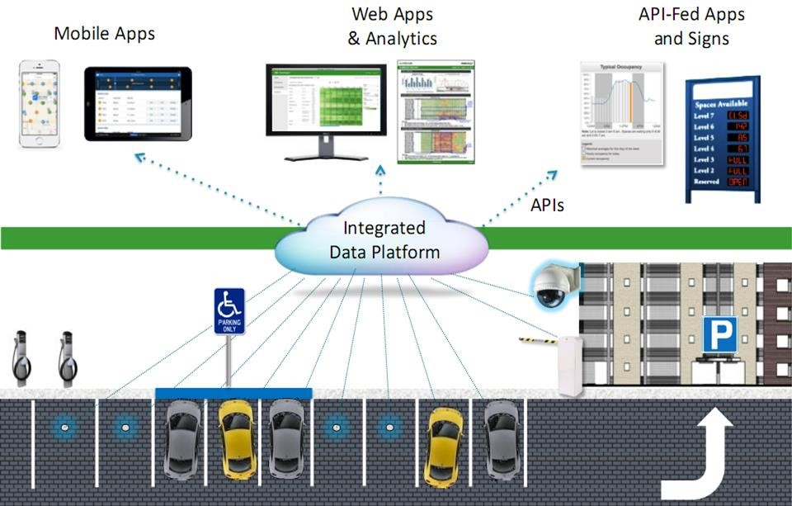

Parking Issues in India:

India has more than 40 million vehicles. But the traffic on roads and parking space has been an area of concern in majority of Indian cities. In most of the cases, 40 per cent of the road space is used for parking rather than for traffic movement on a normal working day. With affordable cars launching in the market, almost every middle-class family owns a car which adds to the vehicular population in our country. If this trend is followed, no amount of space will be enough to accommodate stationary vehicles, which will lead to narrower lanes for movement of public transport.

Parking Solutions Already Prevalent in India:

It is used for optimum utilisation of parking space by utilizing vertical space rather than horizontal space. The growing population and the increase in vehicles have made the plots expensive and hence the conventional parking has become nonfeasible. Car ramps or car lifts also consume a lot of space therefore mechanized car parking systems prove to be feasible. Multi-level car parking system (MLCPS) has a number of advantages over the conventional parking system.



As a conclusion, this project will help in reducing the amount of time a driver has to spend around the parking just to find an available spot, reducing the amount of traffic around the parking and also reducing the bad parking around the parking space.

Adopting parking management system significantly reduces the amount of time consumed in seeking the parking space, renders valuable data upon the availability of the parking area, accurate mapping of the parking space, offers guidance and suggestion for proper vehicle parking.